Problem Set 4

Part 1: 30 Value-Weight Industry portfolios

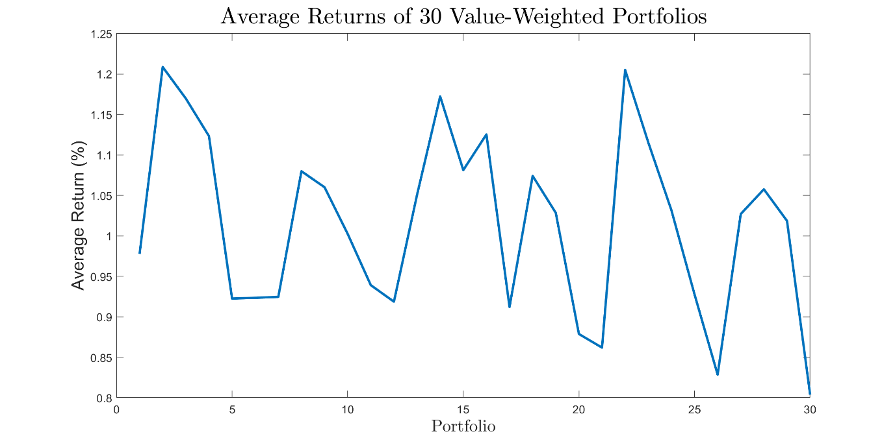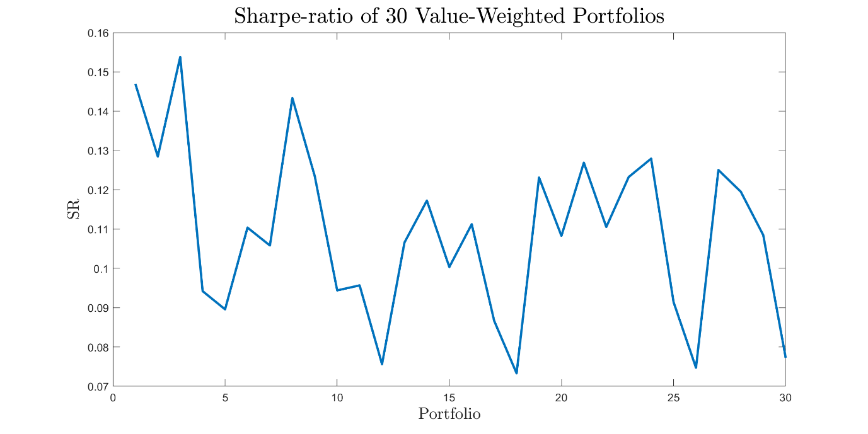

No Discernible patterns? I don’t think there is any discernible patterns. but we can say their SRs .is proportional to their avg returns. They all have around 1% returns, which are small.

1. GRS F-statistic: 1.8895, p-value: 0.0028

We should reject the null hypothesis. The alpha is not zero.

1. Suppose , , ... are intercepts in time series regressions for N assets. The null hypothesis of GRS test is .

GRS test could be used as a test of the efficiency of CAPM model. In CAPM, we only have one factor which is the excess return of the market. GRS tests if the intercept of the time series regression is zero, when there’s only market excess factor. Intuitively, GRS tests if there’s any part significantly different from zero that cannot be explained by the market excess return.

HOW DO THE TS REGRESS IMPLICITLY ESTIMATE THE BETA RISK PREMIUM??

1. All intercepts are positive not all are positive, and the magnitude is from 0 to 0.8%, -0.25%-0.5%approximately. The CAPM in particular has difficulty pricing portfolios like Smoke and Servs. It might because Smoke and Service industry are less influenced by market changes.

Part 2: 10 Past Return portfolios

Repeat a):

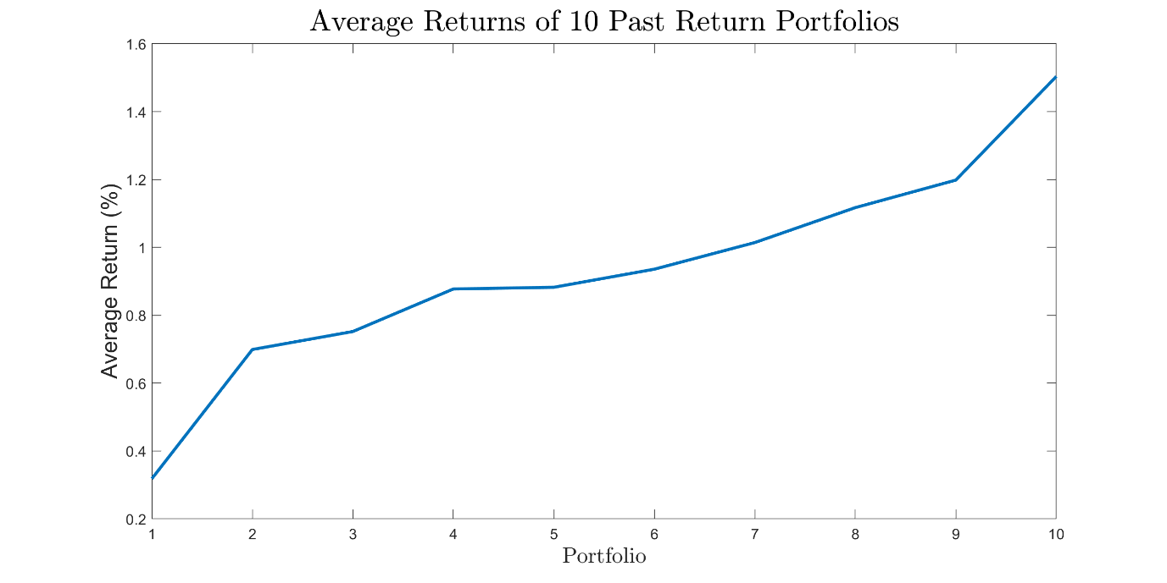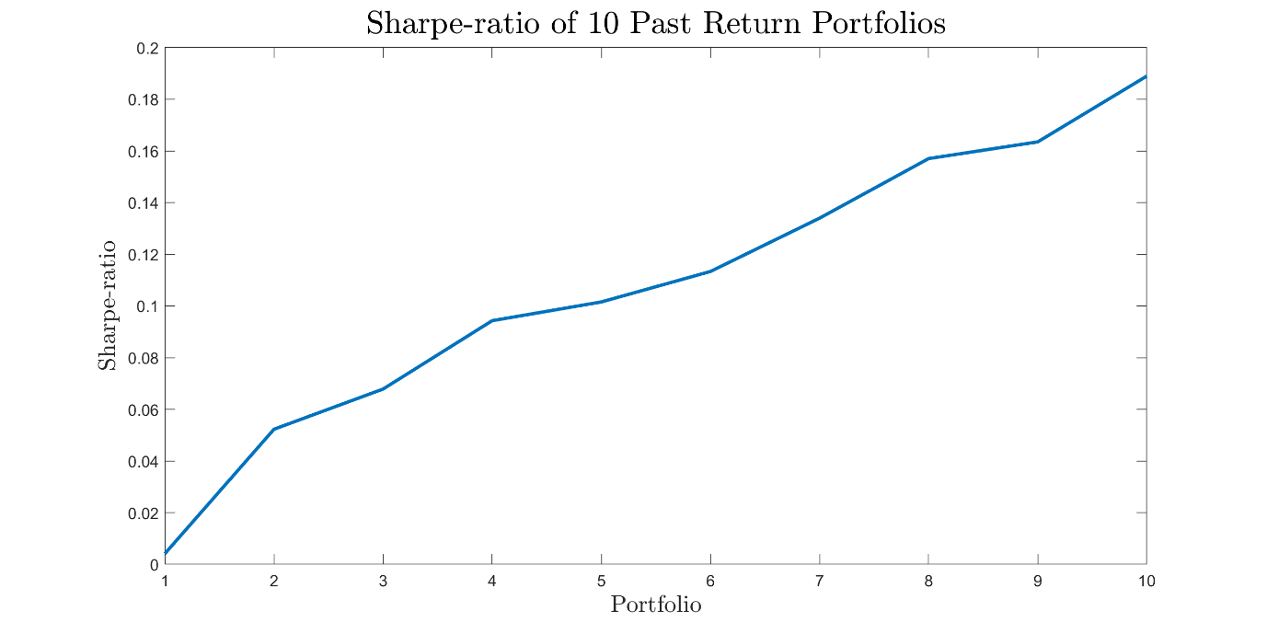

The above plots show the average returns and Sharpe-ratios of the 10 portfolios. There’s positive slope, which means the past winner, compared to the past loser, has a higher return and Sharpe- ratio.

Repeat b)

GRS F-statistic: 6.4757,6.4758 p-value: 9.3300e-10

We should reject the null hypothesis. The alpha is not zero.

Repeat d)

There’s a positive relationship between the performance and the intercepts. The past winner has the highest intercept. From the past loser to the past winner, the signs of intercepts change from negative to positive, and the magnitude is from -1 to 0.6, in particular. CAPM has difficulty pricing the past winner and the past loser, why? Because there are some alphas significantly different from 0.

Part 3: 25 Size and BE/ME portfolios

1. Repeat a):

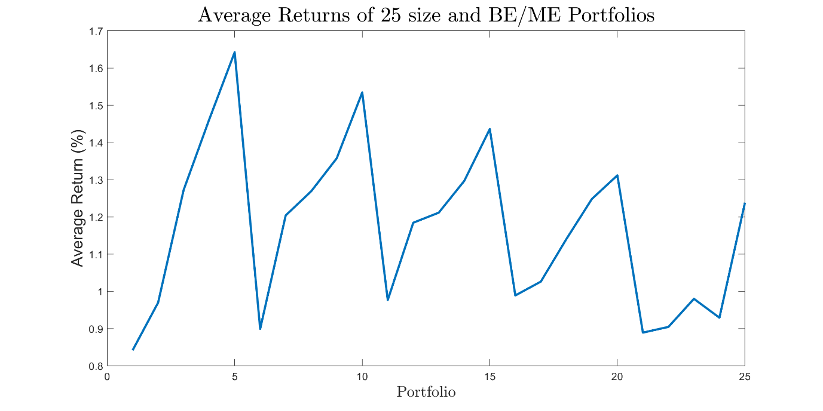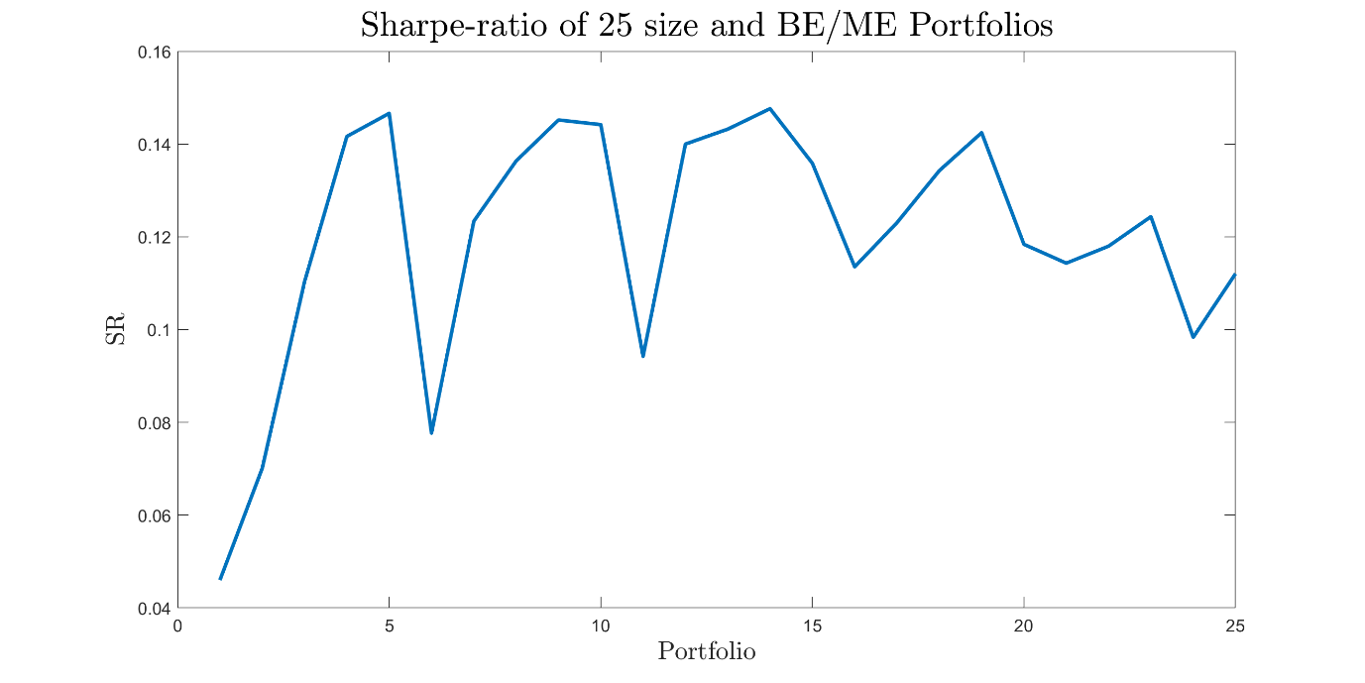

There’s no discernible pattern in the average or sharpe-ratios of the portfolios. It has discernible pattern

Repeat b)

GRS F-statistic: 3.5368,3.5369 p-value: 1.3515e-08

We should reject the null hypothesis. The alpha is not zero.

Repeat d)

There’re positive and negative intercepts. CAPM has difficulty pricing the high BE/ME portfolios, why?

1. GRS F-statistic: 1.1675e-04 1.1744e-04, p-value: 1

When we use tangency portfolio as the market proxy we fail to reject the null hypothesis. This result is not surprising, because the tangency portfolio here is mean-variance efficient.

1. GRS F-statistic: 2.5689 2.6370, p-value: 3.9567e-05

With such small p-value, we reject the null hypothesis. Because this out-of-sample tangency portfolio is not the tangency portfolio for this sample data, and it doesn’t have the same effect as the tangency portfolio. It’s not mean-variance efficient.

1. GRS F-statistic: 3.5742 3.6831, p-value: 9.7878e-09

With such small p-value, we reject the null hypothesis. This model prices the 25 size and BE/ME portfolios very bad. This is not surprising, because this tangency portfolio from other data pool is not the in-sample tangency portfolio. There may be no obvious relationship between asset returns and their betas. It means when we use this portfolio as the market portfolio, CAPM is not a good model. So we reject the intercept being zero.

1. GRS F-statistic: 3.2462 3.3203, p-value: 1.6203e-07
2. With such small p-value, we reject the null hypothesis. This model prices the 25 size and BE/ME portfolios very bad. This is not surprising, because this tangency portfolio from other data pool is not the in-sample tangency portfolio. There may be no obvious relationship between asset returns and their betas. It means when we use this portfolio as the market portfolio, CAPM is not a good model. So we reject the intercept being zero.

|  |  |  |  |
| --- | --- | --- | --- |
|  | 30 VW Industries | 10 past return portfolios | 25 size and BE/ME portfolios |
| 30 VW Industries | 1 | 0.3690 | 0.2258 |
| 10 past return portfolios | 0.3690 | 1 | 0.2436 |
| 25 size and BE/ME portfolios | 0.2258 | 0.2436 | 1 |

Above is the table of correlations. Because the tangency portfolios of 10 past return portfolios and 25 size and BE/ME portfolios don’t have strong correlations with the in-sample tangency portfolio of 30 VW industries, use them as the market proxy lead to the rejection of GRS test.